**Neurodivergent Education for Students, Teaching & Learning (NESTL) Toolkit - Key Resource 3**

**✅ Individual Checklist on Teaching Practices, Space, and Materials**

*This checklist is based on the contents in the section on Individual Initiatives. It is not intended to be prescriptive, and you don’t need to implement all of the suggestions, or all at once. Use it to reflect on your teaching habits and consider incremental changes that can make your teaching more accessible.*

**Lectures and Seminars**

* Provide lesson plans with timings and preparatory materials in advance.
* Avoid setting fixed expectations around how long a task ‘should’ take; acknowledge different working and reading speeds.
* Welcome late arrivals in a warm but non-disruptive way. Avoid practices that shame or isolate students for lateness.
* Use formats such as ‘think, pair, share’ to give students time to process before responding.
* Include at least one substantial break for sessions longer than 60 minutes, ideally between content sections.
* Design breaks inclusively—consider offering options for quiet, movement, socialising, or continued focus.

**Tutorials and Supervision**

* Schedule meetings well in advance using collaborative scheduling tools.
* Clarify expectations for submitting materials (e.g. on the day vs. a few days in advance).
* Provide sustained and compassionate support for students returning from suspension or leave.
* If students have two supervisors, check in early about what supervision format feels most supportive (e.g. 1:1 vs. 2:1).

**Teaching Environments for All Contexts**

* Keep all course information in a central, accessible place (e.g. Canvas).
* Offer hybrid or online learning options where feasible.
* Share logistical information in advance (photos, directions, contact details, etc.).
* Where possible, provide access to quiet rooms or decompression spaces.
* Be mindful of students’ sensory needs, such as sensitivity to light, sound, scent, or touch, and allow or offer adjustments that help them regulate their environment and stay engaged.
* Encourage movement, stimming, use of headphones, and other sensory adjustments. Provide fidget-friendly items or encourage students to bring their own.
* Set guidelines for managing potential ‘access clashes’ in a compassionate, collaborative way.

**Creating a Supportive Social and Psychological Environment**

* Invite students to share their preferred communication styles at the start of term.
* Use tools like traffic-light stickers to support communication boundaries.
* Demonstrate activities step-by-step and don’t assume shared understanding.
* Encourage written contributions alongside verbal ones.
* Normalise silence and avoid negative assumptions associated with silent students and their engagement.
* Conclude sessions with a short summary and reiterate priorities.
* Provide regular opportunities for feedback (e.g. email, office hours).

**Teaching Materials and Delivery**

* Use accessible fonts (sans serif), clear contrast, and limited text per slide or section.
* Read out important text on slides to support comprehension.
* Provide content warnings for potentially distressing material, including references to ableism, so students can prepare themselves emotionally and engage at their own pace.
* Offer summaries of key concepts via visual, written, or interactive tools (e.g. Padlet).
* Record lectures and upload them with captions and transcripts as soon as possible.

**Supporting Transitions and the Hidden Curriculum**

* Offer onboarding documents with names, contacts, and procedures in lab/research environments.
* Explain the ‘hidden curriculum’ to students, including norms and expectations that may not be familiar to all students.

**Check out Relevant Resources on NESTL Canvas**

* Interactive teaching space accessibility checks
* Interactive scenarios of how to handle challenging situations

**For more detailed guidance, examples, activities, and case studies, see the full** [**NESTL toolkit**](https://www.education.ox.ac.uk/project/neurodivergent-education-for-students-teaching-learning-nestl/)**.**

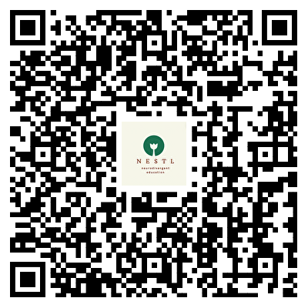

**NESTL Toolkit**