**Neurodivergent Education for Students, Teaching & Learning (NESTL) Toolkit - Key Resource 2**

**✅ Individual Checklist on Awareness, Understanding, and Reflection**

*This checklist is based on the contents in the section on Individual Initiatives. It is not intended to be prescriptive, and you don’t need to tick all of them, or all at once. Use it as a guide to reflect on your practice, identify areas for growth, and take incremental steps towards more inclusive teaching.*

**Self-Learning and Reflection**

* Actively seek out resources to learn about neurodiversity, including resources in this toolkit and on the NESTL Canvas site.
* Reflect critically on your own assumptions about learning, ability, and academic success.
* Reflect on your own identity – could you be neurodivergent, or benefit from practices designed with neurodivergence in mind?

**Ownership and Responsibility**

* Take responsibility for inclusive teaching as part of your everyday role, not only when prompted by policy.
* Be honest with yourself and your students about your current understanding of neurodivergence; view it as an ongoing learning journey.
* Commit to doing at least one thing consistently to support accessibility and inclusion in your teaching.
* If you are in a secure or senior role and if you can, use your influence to advocate for systemic improvements.

**Learning from Students**

* Ask students about their needs in a respectful and non-intrusive way.
* Ensure students understand how their shared information will be treated and under what circumstances confidentiality might be broken.
* Include an accessibility statement in your syllabus, outlining your commitment and ways to communicate access needs.
* Check in with students periodically and invite them to revise or update their access needs as things evolve.

**Understanding Masking and Hidden Needs**

* Educate yourself about masking, particularly in autistic and ADHD students, and avoid assuming that silence means no difficulty.
* Recognise that many students may appear high-achieving while struggling privately. Build in flexibility by default.

**Community and Shared Labour**

* Consider how you can contribute to inclusive practice within your team or department.
* Coordinate with colleagues to offer a range of accessible practices rather than relying on one person.
* If you are neurotypical, be mindful of the emotional labour often carried by neurodivergent colleagues and offer support where possible.

**Safety and Disclosure for Neurodivergent Staff**

* If you are neurodivergent, consider connecting with supportive communities, such as peer networks or affinity groups, that affirm your identity and can offer solidarity, inspiration, and resources, whether or not you choose to disclose.
* Understand that disclosing neurodivergence may not be safe or desirable for everyone, especially those in precarious roles.
* Focus on inclusive actions over disclosure—educators do not need to “come out” to make meaningful change.

**For more detailed guidance, examples, activities, and case studies, see the full** [**NESTL toolkit**](https://www.education.ox.ac.uk/project/neurodivergent-education-for-students-teaching-learning-nestl/)**.**

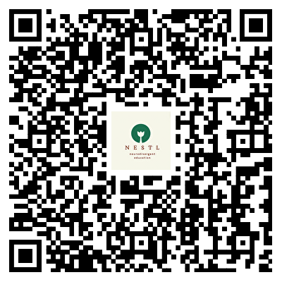

**NESTL Toolkit**